# WILDU INDUSTRIAL SERVICES and BOWHILL ENGINEERING

## **A business partnership empowering Aboriginal to become business owners, generate wealth and to educate and develop regional communities.**

Wildu and Bowhill have thrown out the old model for Aboriginal and community engagement. Historically, government, educators and the commercial sector focused on grants, scholarships and placements as the best way to educate and employ Indigenous. Although good for a few, this does not change the trajectory of future generations, regional community or the greater tribe.

Any solution not focused upon future generations, community and tribe, will under-deliver, if not completely fail.

To break this pattern, Wildu and Bowhill Engineering have gathered some of South Australia’s most successful business leaders in Heavy Construction, Private Equity and Investments, Quality and Compliance, and Major Projects. Working under NAIDOC Elder of the Year, Parry Agius, this team has created an Aboriginal Owned commercial enterprise and social eco-system. Together, our business and social entities have the mandate to:

* Win and deliver major work scopes
* Delivery is at Commercially Competitive Rates
* Profits (open book account) fund social outcomes.
* Using an Aboriginal self-determination model
* Focuses on regional communities

Our enterprise is a first for Australia, however, is based upon the proven economic principles of New Zealand’s $68.7 Billion Iwi Economy. A successful long term business model valued nearly 300% higher than Australia’s Aboriginal Industry, despite New Zealand’s far smaller GDP and economy.

By charting such a bold departure from the norm, we’ve adopted a whole new model of Indigenous Business, pulled together some of South Australia’s best and brightest, so that Wildu and Bowhill can create and deliver the Australian-First of:

* Aboriginal Business and Social Ecosystem that is commercially competitive,
* Financially sustainability without grant, gift nor charity,
* Rapidly scalable to service $1M to $100M scopes, and
* Designed to enable generational change for Aboriginal and regional communities.

If you would like to know more about this exciting opportunity, or to discuss how we can deliver major projects for you, please do not hesitate to contact the undersigned.

Parry Agius - Managing Director – Wildu Jodie Hawkes – CEO – Bowhill Engineering  
[parry@wildu.com.au](mailto:parry@wildu.com.au) - 0419 814 060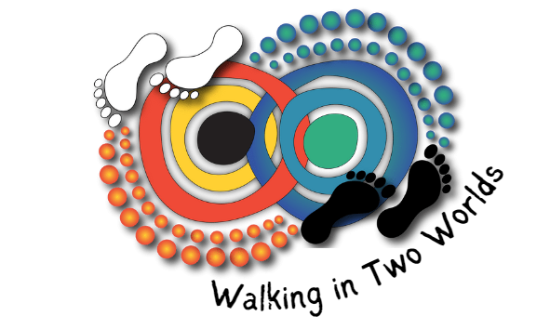 [jodie@boweng.com.au](mailto:jodie@boweng.com.au) – 0438 704 229